**Information and Products for Your**

**Miniature Australian Shepherd**

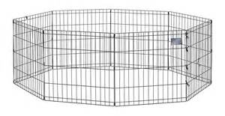

[**www.chewy.com**](http://www.chewy.com)

**I recommend the 36” high size**

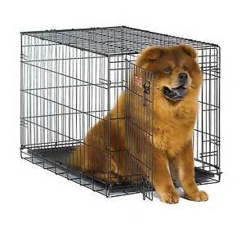

[**www.chewy.com**](http://www.chewy.com)

**I recommend the 42” crate. Single door only. There are many brands available and all are excellent!**

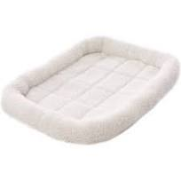 [**www.chewy.com**](http://www.chewy.com)

The Frisco Crate Mat Pet Bed, Ivory, makes your pet’s crate, carrier, kennel, favorite spot or home away from home even cozier. The quilted fleece bed is made with ultra-soft Sherpa material with a foam pad on the bottom for extra cushioning. As your pet curls up and nestles into the perfect position, he can rest his head on the thick, comfy bolster that’s filled with polyester fiber for added support. No matter whether you’re traveling or simply crate training, your faithful companion will feel right at home with this snug, cozy mat. It also makes a quick and easy bed on its own and a safe spot for your pet when you’re on the go. For easy cleaning, you can throw it in the washer and dryer, and it even has a handy loop if you choose to hang it to dry.

Key Benefits

* Perfect for crates, carriers and kennels at home or on the go
* Ultra-soft Sherpa material with foam padding and polyester fiber bolster for extra cushioning
* Cushioned bolster is filled with polyester fiber for added support and makes a comfy headrest
* Machine washable and dryer safe for easy cleaning, and even has a handy loop if you choose to hang it to d

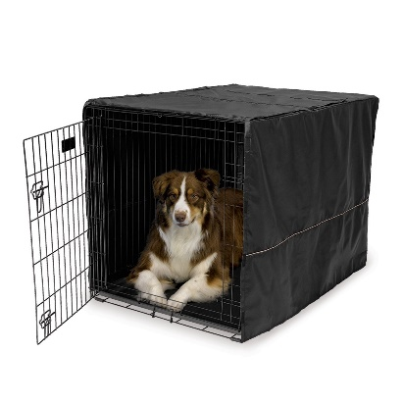

[www.chewy.com](http://www.chewy.com)

MidWest Crate Covers provide your pet with a quiet, private sanctuary of their own! The easy-to-use crate cover simply slips over the top of your MidWest crate, providing your pet with a relaxing environment to sleep while you are away! The crate cover offers proper ventilation and can be used with 1, 2, or 3 door crates, allowing entrance and access from multiple sides. The crate cover also allows access to the slide-out plastic pan in your crate for easy removal and cleaning. Available in Black in six sizes.

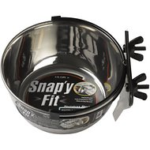

[www.chewy.com](http://www.chewy.com)

**MidWest Stainless Steel Snap'y Fit Dog Kennel Bowl. 4 Cup**

There are many stainless-steel bowls on the market, but none like the Snap'y Fit Bowls! The Snap'y Fit patented system holds the bowl firmly in place and yet, allows easy removal. Pet parents have been frustrated for years with conventional water bowls because pets can dislodge the bowls and spill the food and water. The Snap'y Fit patented system solves this problem by locking securely in place with the grommet hanger. The bowls are available in 10fl. ounce, 20 fl. ounce, 4 fl. cup & 8 fl. cup (1 and 2 qt.) sizes. The 4 cup are perfect for puppies and dogs alike. Perfect for water and feeding in your crate.

YOU MAY ALSO BUY A CRATE KIT FROM US THAT INCLUDES THE CRATE, THE CRATE PAD, THE CRATE COVER AND TWO BOWLS LISTED ABOVE FOR $120.00.

 ** **

[www.chewy.com](http://www.chewy.com) DO NOT ORDER FROM AMAZON! They do not keep kibble refrigerated!

25lb Bag Auto ship every three months for best pricing. You can go back in to your account and make your auto ship shorter or longer depending on the amount of food you are using. Every time you feed your Aussie, there should ALWAYS be kibble left in the bowl!! If there is not, then you aren’t feeding your puppy/dog enough!!

You will change over to adult kibble when your puppy is NINE months old! Please do not switch brands of dog food. I have researched dog foods and have taken many classes on dog nutrition and highly recommend Merrick Whole Earth Farms for your dog for a lifetime!

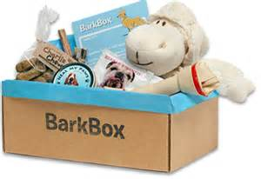

**www.barkbox.com/r/VXXBBE1HPO** Must use the code to get your free month.

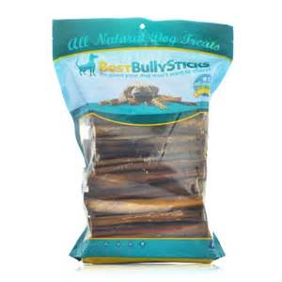

**YOU CAN GET YOUR FIRST BAG FROM ME!**

[**www.bestbullysticks.com**](http://www.bestbullysticks.com)

**I recommend the 6” standard size.**

**If you auto ship you will save an additional 12-18%**

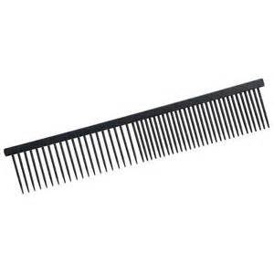

[www.chewy.com](http://www.chewy.com)

Andis steel pet comb 7.5” Do NOT use a brush on your dog at any time. It will tear out their top coat as well. You can also buy a REAL Greyhound comb from [www.ashleycraig.net](http://www.ashleycraig.net) This is where I purchase mine because they have a lifetime warranty that they do honor and they are also hand polished so they are much smoother and better for your dog’s coat.

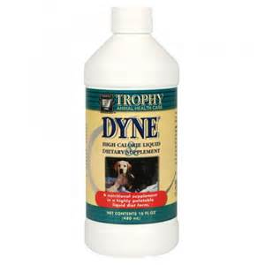

**A SMALL BOTTLE IS GIVEN WITH EACH PUPPY!**

[**www.chewy.com**](http://www.chewy.com)

**I recommend this!** Dyne is a delicious, easy way to provide high-calorie nutrition for dogs recovering from illness, working dogs, or when dogs are recovering from spay/neutering. Vanilla-flavored liquid dietary supplement contains 150 calories per ounce in a palatable, easy-to-administer formula that dogs lap up quickly. Can be fed orally with a syringe or dropper or added directly to drinking water. Provides high-quality calorie intake for recovering animals or underweight puppies that are not able to eat solid food. Please call me before you dose your dog with Dyne.

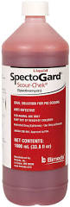

You may buy this from me also for a discounted price!

[www.tractorsupply.com](http://www.tractorsupply.com) This product is great to keep on hand to stop diarrhea in dogs that can lead to dehydration quickly. 1 cc per 10 lbs. given orally with a syringe. This is something you really should purchase. You will use this over the course of your dog’s lifetime I promise!

# How Does Pumpkin Help My Pet's Digestive Health?

If you have a pet, you probably already know that minor [digestive upsets](http://www.1800petmeds.com/education/digestive-concerns-pets-30.htm) can be a common occurrence in pets. It's no fun for a pet to have an upset stomach, but what can you do when you notice that your dog or cat has a case of [diarrhea](http://www.1800petmeds.com/education/diarrhea-dog-cat-30.htm) or is straining to pass stool? If your pet's intestinal distress is minor, a healthy, natural treatment may already be in your own pantry. Surprisingly, plain, unsweetened cooked pumpkin can help with both diarrhea and constipation. You can give your dog or cat plain canned, puréed pumpkin or fresh, cooked pumpkin. Be sure not to use pumpkin pie filling which has added sugar and spices.

**How much pumpkin should I give a dog or cat with constipation or diarrhea?**

It doesn't take much pumpkin to see results. For a small dog or cat, start with a ½ teaspoonful, increasing to one or two teaspoons if necessary. For large dogs, start with a tablespoonful of canned pumpkin and slowly increase the amount if needed. You should see improvement in your pet within a few hours.

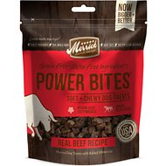

[**www.chewy.com**](http://www.chewy.com)

You may also purchase Merrick training treats for teaching commands. They will not fill your dog up during training sessions.

Nutro Ultra Grain Free All-Natural Biscuits can be ordered from many sources online and found at most major pet stores and specialty pet stores and also come in a small breed formula that is great for puppies.

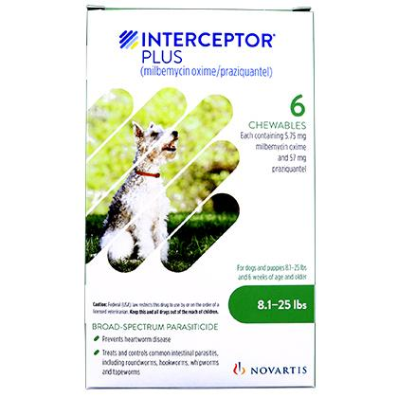 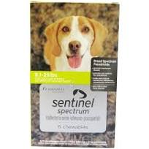

Heartworm Medicine

**The ONLY kind of heartworm medicine that I recommend that can be given to your Mini Aussie is Sentinel Spectrum or Interceptor Plus. Sentinel needs to be SPECTRUM!**

**What I recommend for the best overall protection from fleas, ticks, and worms is to use Interceptor Plus and Bravecto.**

Trifexis is a deadly heartworm medicine, and I do not support nor recommend this drug for your dog. **The use of Trifexis will also null and void your health guarantee.**

1-800-PetMeds [www.1800petmeds.com](http://www.1800petmeds.com) is also the best priced heartworm priced meds by far and your vet can send a prescription to them or the company will also fax a request to your vet which is the method I use. Make sure your vet knows they will be getting a fax from them and also have your vet’s fax number handy when you are ready to place your online order. **Order a YEAR at a time so that you will not need to have your dog tested before then.**

**I do not care what your vet tells you is safe, not following these directions could cost your dog its life!!**

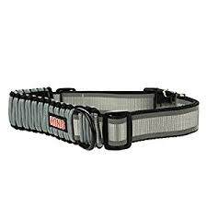**These are found at your local PetSmart or online. A Kong Collar is the sturdiest and longest lasting collar and leash we have ever come across. We buy ours from PetSmart. The size for MOST puppies is a SMALL. WE DO START OUR PUPPIES OUT ON A CAT COLLAR WITH A BELL FOR THE FIRST MONTH SO IT IS EASIER TO KEEP TRACK OF THEM IN THE HOUSE.**

**THIS BOOK IS GIVEN FREE TO ANYONE WHO BUYS A PUPPY!**

[**www.austalian-shepherd-lovers.com**](http://www.austalian-shepherd-lovers.com)

Congratulations. By having this book, you’ve taken the first step towards creating a more harmonious home life for you, your family, and your dog. Training your Australian Shepherd is an important part of being a responsible dog owner. Your Aussie can bring a lot of joy to your life – but there’s also a lot of frustration involved when you can’t get your dog to do what you want. That’s why this book exists. It’s designed to be a simple guide to training, specific to Australian Shepherds. It will cover problem behaviors

specific to Aussies and highlight the best practices and techniques for getting positive results with your Aussie training efforts. There are lots of generic dog books out there. They can give you an overview, but they can’t give you the same insight a book on your specific breed provides. This book takes the best techniques from the most cutting-edge developments in dog training and presents you with the ones that work best for Australian Shepherds.

Apply the principles and techniques contained in this book and you will begin to see a huge

improvement in your dog’s responsiveness to your commands and his or her overall behavior.

**How to Use This Book for the Best Results**

The advice in this book is meant to be put into practice. We’ll discuss a lot of the theory behind training your dog, but theory is no good if it’s not followed by practice. Training is about practice– it’s about repetition.

That’s why I want to provide a few words of warning here: reading this book is not enough

on its own. You must make the commitment to applying the information here if you want

to see results. Even as I write this, I know some readers will read the book and never apply it. This message is addressed to you, the reader who really wants to see huge breakthroughs in the behavior and obedience of your Aussie.

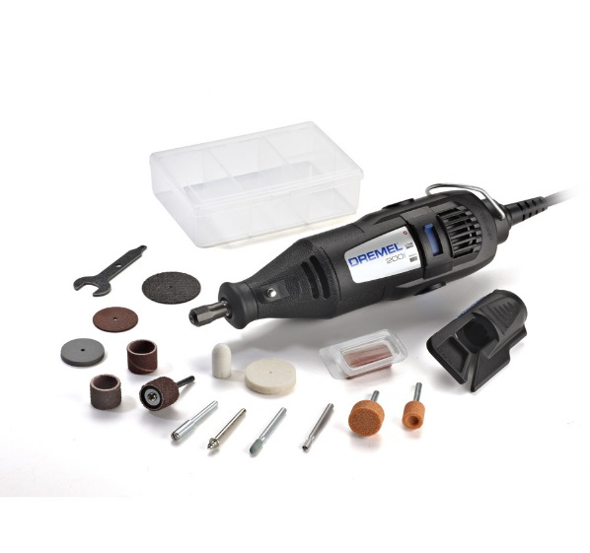

www.lowes.com

Dremel 200 Series 17-piece rotary tool kit includes rotary tool and 15 assorted accessories for carving, grinding/sharpening, cutting, cleaning/polishing, sanding and miscellaneous tasks. **You will need to also purchase a 240 grit pack for your puppy** and move to a 180 grit pack when you are doing an adult dog.

Dremeling dog nails is a fantastic alternative to the traditional method of clipping dog nails. It is not surprising that many dogs react badly to nail clipping. Even if you do not cut painfully into the quick, the motion of clipping still pinches the sensitive nerves within the nail. Dremeling is a great way to maintain healthy nails, and to lessen stress for everyone involved. You don’t have to be a professional to do a good job, but, there are some important steps involved in properly Dremeling nails. ***There are some great videos on the internet on techniques for doing your dog’s nails with a Dremel!***

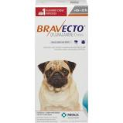**What is Bravecto**?

Bravecto is the first oral chew for dogs to provide up to 12 weeks of protection against fleas and ticks. One chew provides broad-spectrum and long-lasting protection that starts to kill fleas within 2 hours and controls 4 tick species (black-legged tick, American dog tick, brown dog tick, and lone star tick). Bravecto eliminates current flea infestations and prevents new ones from developing for 12 weeks. With one chew, Bravecto is easier to give and less to worry about for you! Bravecto requires a prescription from your veterinarian.

For: Dogs and puppies (over 4.4 lbs. and 6 months of age or older)

Benefits:

* With one dose, Bravecto resets the clock on flea and tick protection by providing effective prevention and treatment for both fleas and ticks for up to 12 weeks.
* Close to a full year of protection with only 4 doses. No more monthly dosing!
* No potential for messy application issues and no need to isolate from children or other pets after treatment
* Fewer doses mean fewer chances to miss a dose decreasing the likelihood of having gaps in protection
* Dogs love the taste!

How does Bravecto work:

After giving your dog Bravecto, the medication quickly reaches tissue fluids under your dog's skin. When fleas and ticks feed on your dog, they ingest Bravecto and die. Bravecto kills fleas, prevents flea infestations and kills ticks (black-legged tick, American dog tick, and brown dog tick) for 12 weeks. Bravecto also kills lone star ticks for 8 weeks.

Active Ingredient(s): Fluralaner

What is Bravecto used for:

Bravecto kills adult fleas and is indicated for the treatment and prevention of flea infestations (Ctenocephalides felis), and the treatment and control of tick infestations [Ixodes scapularis (black-legged tick), Dermacentor variabilis (American dog tick), and Rhipicephalus sanguineus (brown dog tick)] for 12 weeks in dogs and puppies 6 months of age and older and weighing 4.4 pounds or greater. Bravecto is also indicated for the treatment and control of Amblyomma americanum (lone star tick) infestations for 8 weeks in dogs and puppies 6 months of age and older and weighing 4.4 pounds or greater.

Bravecto can be used in adult dogs, and it's even safe for use in breeding, pregnant, and lactating dogs. For use in growing puppies, they should be 6 months of age or older and weigh at least 4.4 lbs.

How to administer Bravecto Chews for Dogs: Bravecto should be administered orally as a single dose every 12 weeks according to the dosage schedule (How to Use tab) to provide a minimum dose of 11.4 mg/lb. (25 mg/kg) body weight. Treatment with Bravecto may begin at any time of the year and can continue year-round without interruption.

Availability: Bravecto requires a prescription from your veterinarian.

What special precautions are there? Bravecto has not been shown to be effective for 12 weeks’ duration in puppies less than 6 months of age. Bravecto is not effective against Amblyomma americanum ticks (lone star ticks) beyond 8 weeks after dosing. How should I store this product? Do not store above 86°F (30°C).

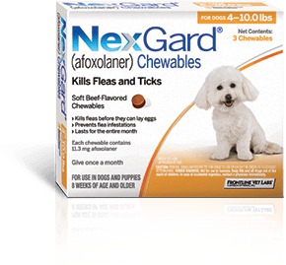

The fast-acting formula is safe and effective for an entire month.

### From the maker of FRONTLINE® Flea & Tick Products—a brand you can trust. NexGard soft chew is FDA-approved, and proven safe and effective for use in dogs and puppies 8 weeks of age or older, weighing 4 pounds or more. It contains an ingredient, afoxolaner, that kills both fleas and ticks quickly and keeps killing for a whole month.2 So it helps provide protection you can feel good about. *NexGard* for Dogs kills adult fleas before they lay eggs to help prevent infestations. Plus, *NexGard* also kills the Lone Star tick, Black-legged tick, American Dog tick and Brown dog tick.

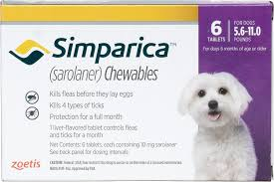

#### What is Simparica?

Simparica® (sarolaner) Chewables are safe, monthly flea and tick protection for dogs that start working fast and remain effective all month long. Simparica starts killing fleas within 3 hours and ticks within 8 hours, * and it keeps going strong for 35 days* without losing effectiveness at the end of the month. Proven persistent protection against fleas and ticks. Simparica is effective against fleas and ticks, even on day 35! * You can count on Simparica to do the following:

* Provide rapid relief for pets with existing flea infestations, even dogs with flea allergies
* Improve clinical signs of flea allergies in dogs by eliminating fleas
* [Prevent and control home flea infestations, killing fleas before they can lay eggs](https://www.simparica.com/how-does-simparica-work.aspx)
* Quickly kill ticks, which may help reduce the risk of potentially life-threatening flea- and tick-borne diseases1-4

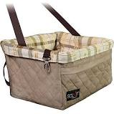[www.chewy.com](http://www.chewy.com)

The large is perfect size for an Aussie**.**

**Solvit Deluxe Tagalong Pet Booster Seat** Solvit's design supports the seat from below, providing an unobstructed view and more comfortable ride for pets – no clumsy straps to get in their way. Installs securely in one minute on any seat with separate headrests! Each has a removable, washable liner so they stay clean and fresh. Safety leash included.

Key Benefits

* Elevates pets off the car seat so they can watch the world go by, with no clumsy straps to impair their view or their comfort.
* Padded interior and an internal harness attachment to create a secure ride for your dog.
* Installs securely in one minute and even works in the back seat!
* Machine washable cover with reversible pillow
* There's a front storage pocket for favorite toys, treats or leashes.

### Special Note-The Large and X-Large hang from the vehicle headrest. The Jumbo sits on the vehicle seat. I use all of mine on the seat of my cars!

# Solvit Deluxe Car Safety Dog Harness, SmallSolvit Deluxe Car Safety Dog Harness

# [www.chewy.com](http://www.chewy.com)

This item needs to be fit for YOUR puppy or dog, and you may have to get a larger size as they grow**. This item must be bought with your car seat!!**

The ultimate in protection and comfort. The Solvit Deluxe Car Safety Harness offers a smooth, safe, comfortable road trip for you and your dog. The Solvit Deluxe Car Safety Harness is designed with your dog’s safety and comfort in mind. This totally new design has been crash-tested in a DOT-approved facility according to leading industry standards. The harnesses have also undergone extensive static testing to 3000+ lbs. to ensure strength and durability. The safety harness integrates smoothly with your vehicle's seat belt system, providing range of motion while traveling and security in the case of a sudden stop. Strength-rated straps attach to a fully padded vest, with a breathable inner layer for optimal comfort. These safety harnesses also improve safety by reducing driver distraction. A handy walking leash attachment point makes it easy to transition to and from the car.

### Key Benefits

* Improves safety by reducing driver distraction and restraining pet in case of sudden stop
* Crash tested in DOT-approved facility and stress-tested to 3000+ lbs.!
* Fully-padded vest with breathable liner provides superior comfort and safety
* Includes convenient connection point for walking leash
* Fully adjustable to fit all dogs within each size range

# Surgi Snuggly Wonder Suit Post Surgical Healing Dog Suit, Small LongSurgi Snuggly Wonder Suit Post-Surgical Healing Dog Suit [By Surgi Snuggly](https://www.chewy.com/s?rh=brand_facet%3ASurgi+Snuggly)

# Amazon and Chewy both sell this wonderful shirt for post-surgery care.

**Remember to measure your pet for the paw-fect fit.** Help your canine companion feel comfortable and comforted with Surgi Snuggly Wonder Suit Post-Surgical Healing Dog Suit. This red and blue suit is specially designed for dogs recovering from surgery. It has a thoughtful design that helps keep diapers and bandages on your pet, can aid hot spots and help reduce anxiety. It’s also made with a breathable and antimicrobial material to help fight germs, fungus, mold and mildew. The stretchy fabric and flat seams not only help your dog feel cozy, but they can also reduce the likelihood of uncomfortable rubbing. And one of the most convenient features on this Wonder Suit is that it’s easy for your pup to go potty—just fold the bottom into the back pocket!

Key Benefits

* Onesie helps protect your pet so he can heal in comfort.
* Helps relieve post-surgery anxiety.
* Invented by a vet with over 40 years of experience and used by veterinarians, trainers and pet professionals across the nation.
* Made with antimicrobial material to help fight germs, fungus, bacteria and more.
* Designed with WaGS—a signature sizing system that helps ensure a proper fit by looking at your dogs weight, girth and spine measurements.

Precautions

As with any pet product please evaluate your pet’s reaction to this product. Check underarms to ensure the fit is not too snug! Discontinue use if you notice chewing or biting.

# Full Moon All-Natural Human Grade Dog Treats, Chicken Strips Chewy has better selection but Amazon has them too.